SOFTWARE REQUIREMENTS ENGINEERING
Lab Report
Identifying Sources of Requirements and Applying the Kano Model
Case Study: University Course Registration System
Group Members
Hudaibia
Sarah Arif
Eshaal Nazir
Abdul Samad

Course: Software Requirements Engineering (SRE)
Submitted to: Sir Fahim Muhammad Khan
Date: September 24, 2026

1. Introduction
For this lab our group worked on two related tasks. First, we looked at where the requirements for a new software system should actually come from. Second, we used the Kano Model to understand how students feel about specific features of that system. The case study given to us was a university that wants to build a new Course Registration System. Right now, students have to check course availability manually, sometimes by visiting the registrar's office, and there is no single place where searching, registering, and confirming a registration happen together. Our job in this lab was to figure out who this system's requirements should come from, list out candidate features, build a Kano questionnaire for those features, collect responses from real students, and analyze what those responses tell us about which features actually matter.

2. Case Study Background
The university in this case study wants a system that lets students search for courses, check how many seats are left, register, receive confirmation, and manage their registration afterwards, all in one place. A system like this affects a lot of different people, not just students but also registrar staff, faculty, and the university's IT department, so before deciding what features to build, we needed to think about where the requirements for this system should come from and who should be asked.

3. Task 1: Sources of Requirements
As a group we identified the following eight sources of requirements for this system:
Source | Example | Information Obtained
Students / End Users | Students registering for courses | Goals, problems, usability needs, preferences
Registrar / Academic Office | Registration staff | Rules, approval process, policies
Faculty / Instructors | Course instructors | Prerequisites, capacity, instructor constraints
IT / System Administrators | University IT staff | Security, infrastructure, integration, technical constraints
Existing System / Process | Current registration workflow | Current functions, limitations, data, workarounds
Documents / Policies | Academic regulations | Mandatory rules, deadlines, eligibility
Observation | Observing students during registration week | Actual behaviour, interruptions, workarounds
Interviews / Meetings | Short discussions with registrar staff and a few instructors | Detailed needs, concerns, exceptions
Surveys | Kano questionnaire sent to students | Opinions and satisfaction patterns across a larger group
External / Comparable Systems | Registration portals of other universities | Common features and alternative approaches
Each of these sources gives a different kind of information. Students told us what they actually want and where the current process frustrates them, the registrar and faculty gave us the rules and constraints the system has to respect, and looking at the existing process and academic policies showed us what already works and what does not. We felt using this mix of sources, instead of only asking students, gave us a more complete picture before we started listing features.

4. Task 2: Candidate Requirements / Features
Based on the sources above, we listed the following ten candidate features for the new system. These are the same ten features we later tested with our Kano questionnaire.
No. | Candidate Feature | Possible Source | Problem Addressed
1 | Search courses by code, title, or department | Students | Finding courses quickly
2 | Display remaining seats | Students / Registrar | Avoiding attempts to register for full courses
3 | Registration confirmation | Students / Registrar | Providing clear status after registering
4 | SMS / email notification | Students / University | Improving communication
5 | Automatic course recommendations | Students / Faculty | Helping students discover suitable courses
6 | Dark mode | Students | Display preference
7 | Download timetable as PDF | Students | Offline access to schedule
8 | Remember selected courses before final submission | Students | Reducing repeated work
9 | Preserve registration data during a temporary network problem | Students / IT | Reducing data loss
10 | Fast response during peak registration | Students / IT | Reducing waiting time

5. Understanding the Kano Model
Before we designed the questionnaire, we made sure everyone in the group understood what each Kano category means, since we would use these same categories later to classify all of our survey responses. The Kano Model looks at how a feature's presence or absence changes user satisfaction. It is important to note that Kano only describes how users react, it does not by itself decide what should be built first; cost, risk, feasibility, and business priorities still matter and have to be considered alongside it.
Category | Meaning | Typical Reaction
Must-be (M) | Basic feature expected by users; its absence causes strong dissatisfaction. | Expected when present; users get frustrated when it is missing.
One-dimensional (O) | Satisfaction rises or falls directly with how well the feature performs. | Better performance means more satisfaction, and worse performance means clear dissatisfaction.
Attractive (A) | Not something users demand, but it delights them when it is there. | Happy when present; little to no dissatisfaction when it is missing.
Indifferent (I) | Has almost no effect on how satisfied a user feels. | Users barely notice whether it is present or absent.
Reverse (R) | Some users actually prefer that the feature does not exist. | Presence of the feature can reduce satisfaction for these users.
Questionable (Q) | The respondent's two answers contradict each other or are unclear. | The category cannot be determined reliably from that response.

6. Kano Questionnaire Design
For every feature we wrote two paired questions, a functional question that asks how the respondent would feel if the feature were present, and a dysfunctional question that asks how they would feel if it were absent. Both questions used the same five answer choices: I like it, I expect it / It must be that way, I am neutral, I can tolerate it / I can live with it, and I dislike it. We were careful to keep the wording plain and neutral so that we would not lead respondents toward a particular answer. The ten functional/dysfunctional pairs we actually used are shown below.
No. | Feature | Functional Question | Dysfunctional Question
1 | Course search | How would you feel if the system allowed you to search for courses by course code, title, or department? | How would you feel if the system did not allow you to search for courses by course code, title, or department?
2 | Remaining seats display | How would you feel if the system displayed the number of remaining seats for each course? | How would you feel if the system did not display the number of remaining seats for each course?
3 | Registration confirmation | How would you feel if the system provided confirmation after you successfully registered for a course? | How would you feel if the system did not provide confirmation after you registered for a course?
4 | SMS/email notification | How would you feel if the system sent SMS or email notifications about your course registration? | How would you feel if the system did not send SMS or email notifications about your course registration?
5 | Automatic course recommendations | How would you feel if the system provided automatic course recommendations based on your academic information? | How would you feel if the system did not provide automatic course recommendations?
6 | Dark mode | How would you feel if the course registration system provided a dark mode option? | How would you feel if the course registration system did not provide a dark mode option?
7 | Download timetable as PDF | How would you feel if the system allowed you to download your timetable as a PDF? | How would you feel if the system did not allow you to download your timetable as a PDF?
8 | Remember selected courses | How would you feel if the system remembered your selected courses before you submitted your final registration? | How would you feel if the system did not remember your selected courses before you submitted your final registration?
9 | Data preservation | How would you feel if the system preserved your registration data during a temporary network problem? | How would you feel if the system did not preserve your registration data during a temporary network problem?
10 | Fast peak-period response | How would you feel if the system responded quickly during busy registration periods when many students were using it? | How would you feel if the system did not respond quickly during busy registration periods?

7. Implementing the Questionnaire in Google Forms
We created a Google Form titled "Kano Analysis — University Course Registration System" with a short introduction explaining the purpose of the survey to respondents. For each of the ten features we added one functional and one dysfunctional question using the same five response options described above, and we kept respondent identification optional. Before sending the form out, two of us tested it ourselves to check the wording and confirm the response options worked correctly.
We shared the form with students and collected 40 complete and partial responses in total, more than the 15 to 30 the lab suggested as a minimum, which gave us a slightly larger sample to work with.
Google Form link: [Insert your Google Form link here]

8. Kano Evaluation Matrix
To turn a respondent's pair of answers into a single Kano category, we used the standard evaluation matrix below. The row is the answer to the functional question and the column is the answer to the dysfunctional question.
Functional \ Dysfunctional | Like | Expect | Neutral | Tolerate | Dislike
Like | Q | A | A | A | O
Expect | R | I | I | I | M
Neutral | R | I | I | I | M
Tolerate | R | I | I | I | M
Dislike | R | R | R | R | Q
For example, someone who says they would like the feature if present and dislike it if absent is classified as One-dimensional, since their satisfaction clearly rises and falls with the feature. Someone who says they would like it both present and absent is marked Questionable, because that pair of answers does not make logical sense on its own.

9. Analysing the Responses
We linked the form to a response spreadsheet and, following the lab instructions, kept the raw responses on their own sheet and built a separate sheet for the analysis instead of editing the raw data directly. We first classified a handful of response pairs by hand to make sure we understood the logic correctly, then applied the same matrix consistently to all 40 responses across all ten features. Our complete workbook (raw responses, the evaluation matrix, the full classification of every response, and the summary shown below) is attached alongside this report as a separate Excel file.

10. Kano Summary Results
After classifying every response we counted how many respondents fell into each Kano category, for each feature. A small number of respondents (between one and four out of forty, depending on the feature) skipped one of the two paired questions, so that particular response pair could not be classified and was left out of the count for that feature only.
Feature | A | O | M | I | R | Q | Dominant
Course search | 15 | 11 | 1 | 8 | 0 | 4 | Attractive (A)
Available-seat display | 12 | 9 | 4 | 9 | 0 | 4 | Attractive (A)
Registration confirmation | 5 | 12 | 5 | 10 | 2 | 4 | One-dimensional (O)
SMS/email notification | 9 | 9 | 2 | 13 | 1 | 4 | Indifferent (I)
Automatic recommendations | 8 | 8 | 1 | 12 | 3 | 4 | Indifferent (I)
Dark mode | 6 | 8 | 1 | 13 | 5 | 6 | Indifferent (I)
Download timetable | 8 | 11 | 5 | 7 | 1 | 6 | One-dimensional (O)
Remember selected courses | 9 | 8 | 3 | 10 | 3 | 4 | Indifferent (I)
Data preservation | 5 | 8 | 3 | 10 | 3 | 8 | Indifferent (I)
Fast peak-period response | 7 | 12 | 5 | 9 | 1 | 5 | One-dimensional (O)

11. Chart
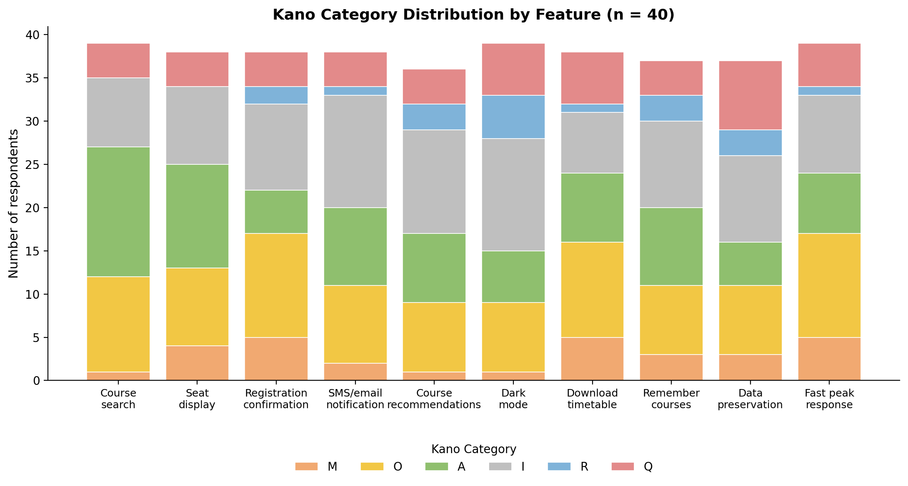
Figure 1: Kano category distribution for all ten features (n = 40).

12. Interpretation of Major Findings
Course search and the remaining-seats display both came out Attractive, meaning students see these as a nice addition rather than something they absolutely demand, though in a system built specifically for registering for courses we would still treat both as central. Registration confirmation, downloading the timetable as a PDF, and fast response during peak registration periods all came out One-dimensional, which means the better these are built, the happier students will be, and the worse they are built, the more students will complain. This makes sense: confirmation, a working timetable download, and the system not slowing down during registration week are all things students directly experience and judge the system on.
SMS/email notifications, automatic course recommendations, dark mode, remembering selected courses, and preserving data during a network problem all came out Indifferent, meaning most students did not feel strongly either way about them. None of the ten features came out strongly as pure Must-be in our data, though registration confirmation and download timetable both had a fairly high Must-be count alongside their One-dimensional lean, which suggests some students already see these as basic expectations rather than bonus features.

13. Explaining One Questionable and One Indifferent Response Pattern
Questionable example: Data preservation during a temporary network problem had the highest number of Questionable responses of any feature in our survey (8 out of 40). We think this happened because the question describes a fairly specific and technical situation, a temporary network problem while registering, and some respondents may not have pictured the same scenario while answering the functional and dysfunctional versions of the question, leading to answers that contradicted each other. This does not mean the feature itself is a bad idea, it means we cannot rely on this particular set of responses to say confidently how students feel about it, and a clearer explanation in the question would likely reduce this number if we ran the survey again.
Indifferent example: Dark mode had the highest Indifferent count in our data (13 out of 40), tied with SMS/email notification. This fits what we expected going in, since dark mode is a display preference and has nothing to do with actually completing a registration. Students can register for their courses whether or not the interface has a dark theme, so most respondents said they would feel neutral or could tolerate it either way. It is worth noting dark mode also had a somewhat higher Reverse count than other features (5 out of 40), meaning a few students would actually prefer the system not to have it at all, possibly due to readability or accessibility concerns, which is a small but real signal worth keeping in mind.

14. Reflection: Using Kano Results for Requirements Prioritization
Working through this lab showed us that a Kano category by itself does not tell the whole story. Course search came out Attractive in our data, but we would not push it down the priority list, since it is one of the very first things a student does in this system and the whole point of the tool depends on it working well. On the other hand, registration confirmation and fast response during peak periods came out One-dimensional, and both also require real engineering effort, confirmation touches the registrar's approval process and fast response depends on the university's server infrastructure, so cost and technical feasibility matter here just as much as the Kano result. Features like dark mode, which came out clearly Indifferent, are reasonable to leave for later or drop entirely if the team is short on time, since building them would not move student satisfaction much either way. Overall, this lab made it clear that Kano results are one useful input into deciding what to build first, but they need to sit alongside cost, risk, dependencies, and business priorities rather than being used alone.

15. Deliverables Checklist
The full set of deliverables required for this lab, and where each one can be found, is listed below:
Deliverable | Where to Find It
Requirements-source table (at least 8 sources) | Section 3 of this report
At least 10 candidate requirements/features | Section 4 of this report
Completed Kano questionnaire (functional + dysfunctional questions) | Section 6 of this report
Google Form link / screenshots | Section 7 of this report
Raw response spreadsheet | Attached Excel file, sheet: Raw Responses
Kano analysis/classification sheet | Attached Excel file, sheet: Classification
Feature-by-feature Kano summary | Section 10 of this report, and Attached Excel file, sheet: Summary
At least one chart | Section 11 of this report, and Attached Excel file, sheet: Summary
Interpretation of major findings | Section 12 of this report
Explanation of one Questionable and one Indifferent pattern | Section 13 of this report
Reflection on Kano and requirements prioritization | Section 14 of this report

16. Group Member Contributions
Even though tasks were divided so we could work efficiently, all four of us went through the complete analysis together and are prepared to explain any part of it in the viva.
Group Member | Main Contribution
Hudaibia | Identified requirement sources, prepared the list of candidate features, and worked on the sources table.
Sarah Arif | Designed the functional/dysfunctional question pairs and built and tested the Google Form used to collect responses.
Eshaal Nazir | Set up the response spreadsheet, applied the Kano evaluation matrix to classify every response, and prepared the summary table and chart.
Abdul Samad | Wrote the interpretation of the results, the Questionable/Indifferent explanation, the reflection section, and compiled the final report.

